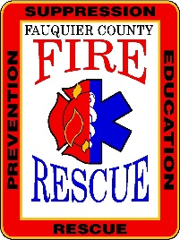
Fauquier County Department of Fire Rescue and Emergency Management
Smoke Alarm Install Request

Resident Information
Name | Number
Email | Address
City | State, Zip
Services Provided
# of smoke alarms installed and tested:
# of carbon monoxide alarms provided:
# of new bed shaker alarms installed and tested (DHH)?
# of batteries replaced?
Initial Assessment Upon Visit
How many people live here?
How many pre-existing smoke alarms does the household already have?
How many pre-existing smoke alarms are working?
Additional Notes:

I am the resident of the home at the address above. Today, I received the services indicated on this form. I also received instructions about how to use and maintain smoke alarms. It is my responsibility to maintain the smoke alarm(s) per the manufacturer’s recommendations and to test the alarm(s) monthly. It is also my responsibility to make sure I have the appropriate type of smoke alarms in my home. Different types of alarms, ionization and photoelectric, detect fires differently and experts recommend having both types. It is additionally my responsibility to make sure that I have the appropriate number of smoke alarms and that the alarms are in appropriate locations. Furthermore, the Fauquier County Department of Fire, Rescue and Emergency Management is not responsible for determining the appropriate type, number or location of smoke alarms.
Your signature indicates that you have read the information above and that you agree with its content.

__________________________________ ______________________________
Resident’s Printed Name Installers Printed Name

__________________________________ ______________________________
Residents Signature Installers Signature

Date ____/____/________ Date ____/____/________
Please return completed form to: DFREM Administrative Offices, 62 Culpeper Street, Warrenton, VA 20186

